Final

1) Ejercicio 1

> vi syslog-to-hdfs.properties

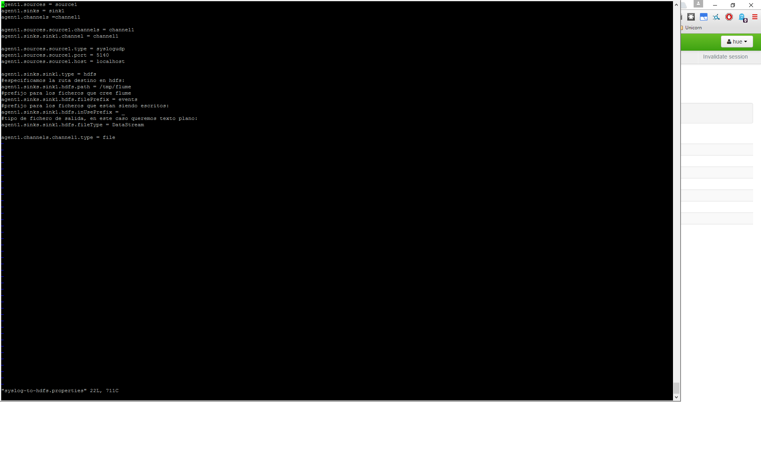

> flume-ng agent --conf-file /usr/hdp/current/flume-server/conf/syslog-to-hdfs.properties --name agent1 --conf /usr/hdp/current/flume-server/conf -Dflume.root.logger=INFO,console

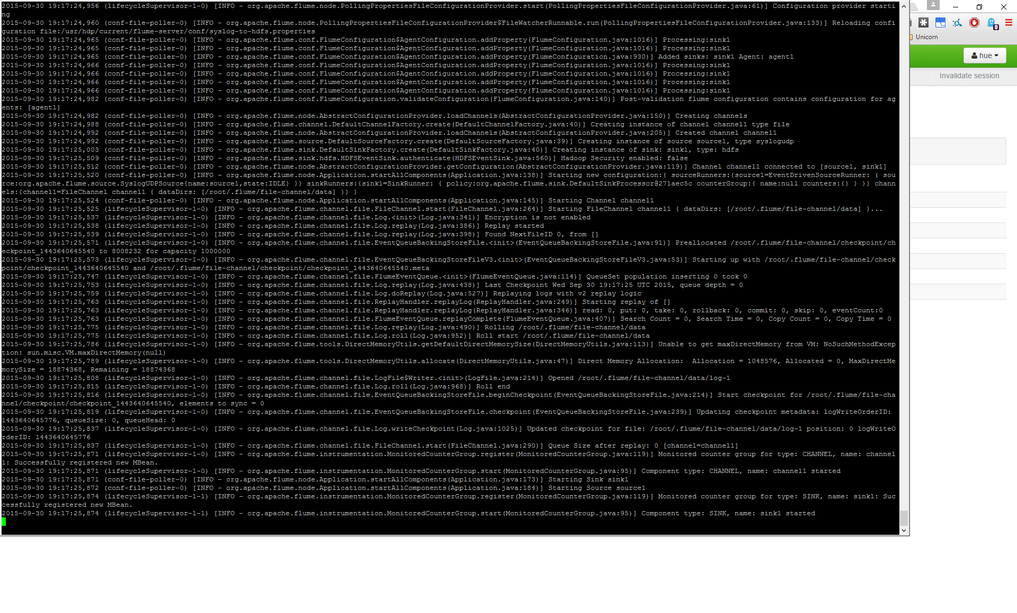

> python syslog_generator.py Alfonso

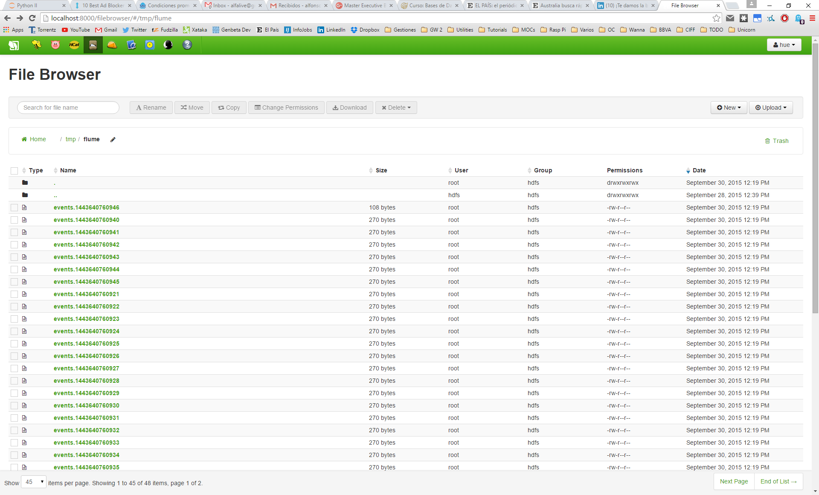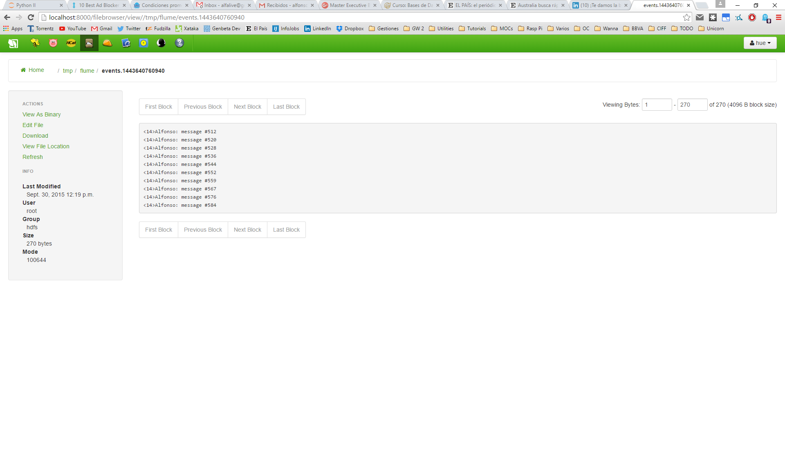

2) Ejercicio 2

> sqoop-import --connect jdbc:mysql://localhost/employees -table employees --target-dir /sqoop/veteran_employees --where "hire_date < '1990-01-01'"

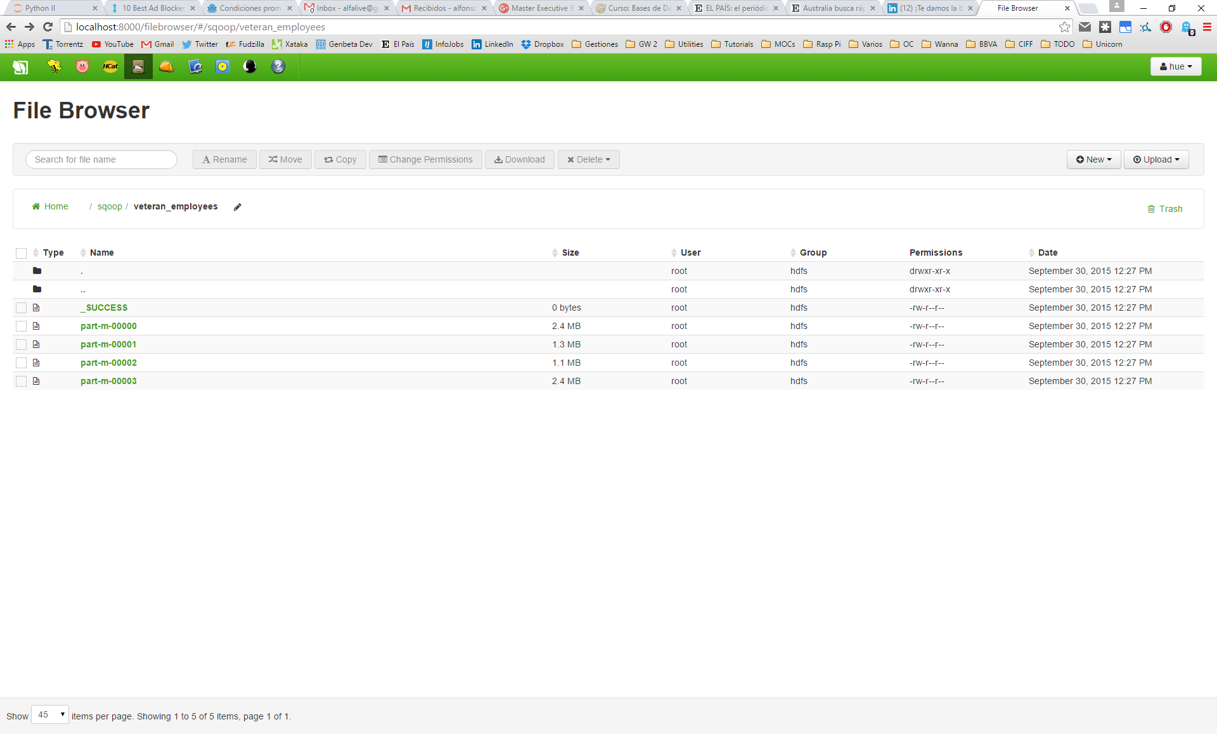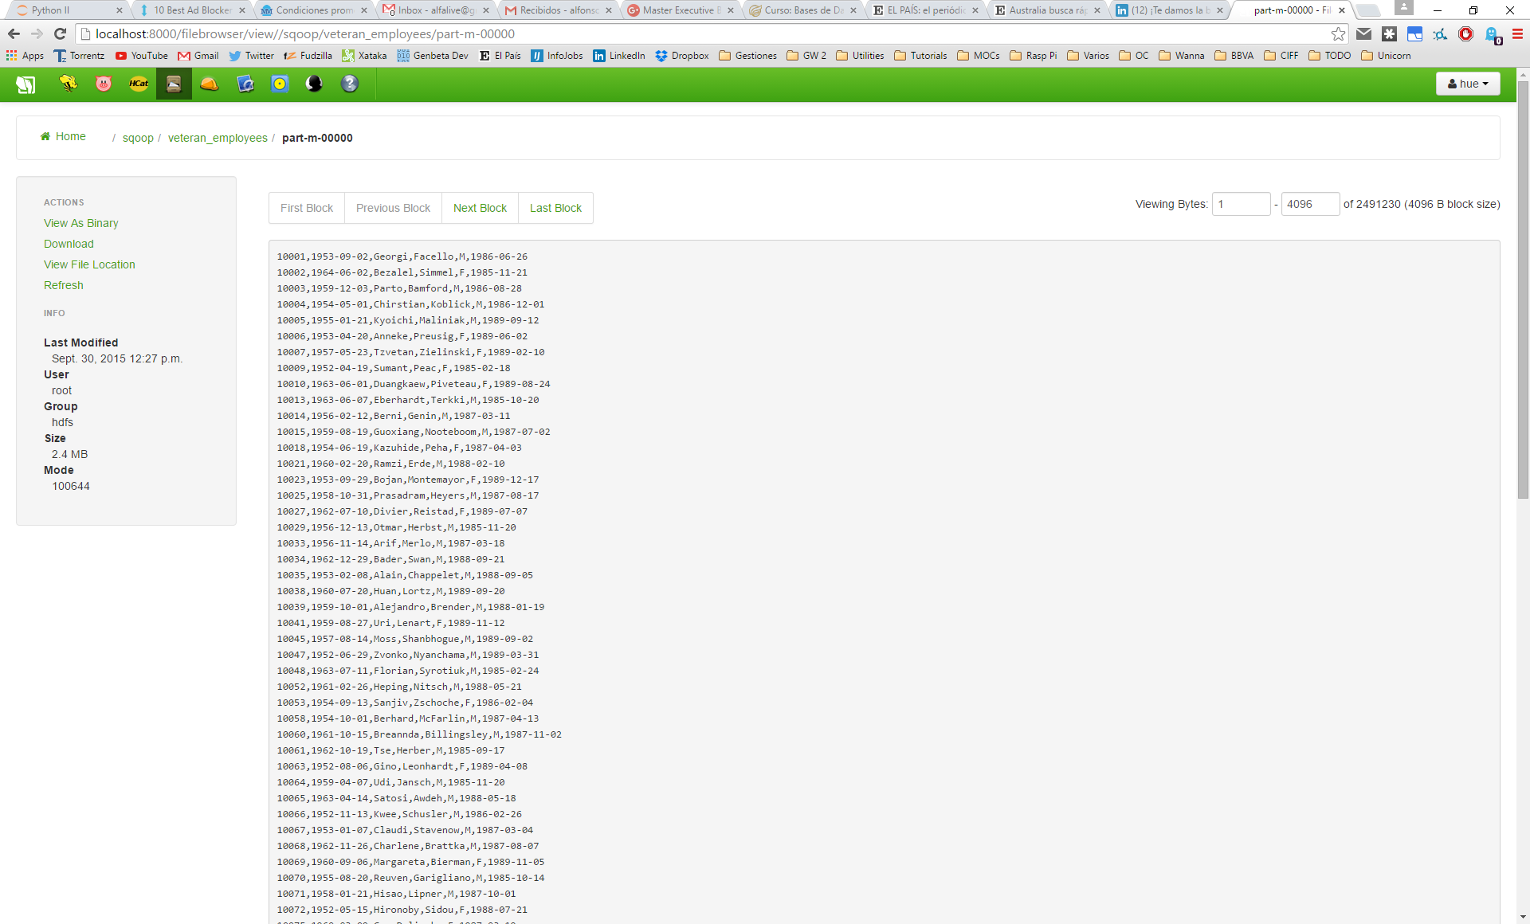

3) Ejercicio 3

> xpath_expr = '//li[@class = "puntoPDF"]/a/@href'

